**Cross compile busy box**

For cross compiling we need a cross compiler

We build one with crossing-tools

The cross compiler libraries were built here:

x-tools/arm-unknown-linux-gnueabihf/bin

We will get back to cross compilation in a second.

I download busybox sources 1.26 ( as for June 2017) from here:

<https://busybox.net/downloads/?C=M;O=D>

**How do I configure Busybox?**

Busy box is configured like the Linux kernel and buildroot, using menu config.

So instead of doing . /configure, make and make install

Do:

**make defconfig** - Create the maximum "sane" configuration. This enables almost all features, minus things like debugging options and features that require changes to the rest of the system to work (such as selinux or devfs device names). Use this if you want to start from a full-featured Busybox and remove features until its small enough.

**make allnoconfig** - Disable everything. This creates a tiny version of Busybox that doesn't do anything. Start here if you know exactly what you want and would like to select only those features.

**make menuconfig** - Interactively modify a .config file through a multi-level menu interface. Use this after one of the previous two.

**make allyesconfig** - Select absolutely everything. This creates a statically linked version of Busybox full of debug code, with dependencies on selinux, using devfs names... This makes sure everything compiles. Whether or not the result would do anything useful is an open question.

**Cross compiling**

We have three options to start make with cross compilation

1. Specify the CROSS_COMPILE= <prefix>

Prefix is the cross compiler, without the gcc , g++

For example:

In our tool chain is:

arm-unknown-linux-gnueabihf-

The end - is important.

We can start at the command line:

make CROSS_COMPILE = arm-unknown-linux-gnueabihf-

Note, the compiler should be in the path

Or you can specify the full path:

make CROSS_COMPILE=/home/user/x-tools/arm-unknown-linux-gnueabihf/bin/arm-unknown-linux-gnueabihf-gcc

Another option is to source it in environment variable:

export CROSS_COMPILE=/home/user/x-tools/arm-unknown-linux-gnueabihf/bin/arm-unknown-linux-gnueabihf-

To store the cross-compiler in your .config, set the variable CONFIG_CROSS_COMPILER_PREFIX accordingly in menuconfig or by editing the .config file.

In busy box settings:

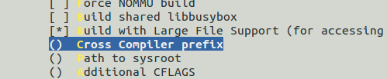

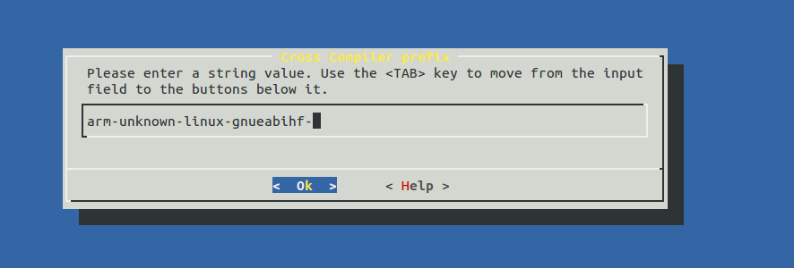

The result is one file called busybox

When we run this, we should get the usage and all the function exists in the busybox binary

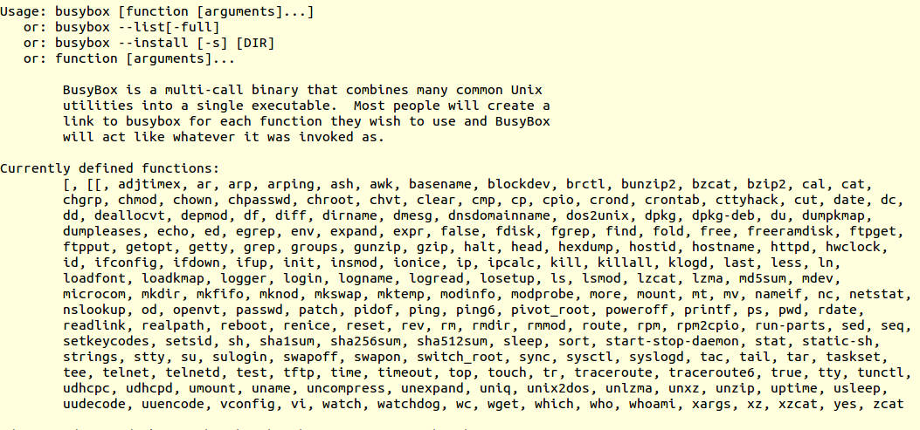

For example, df –k , shows us the disk usage

We can type:

Busybox df –k

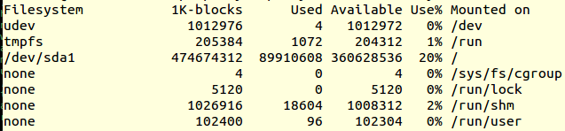

Usually to use that we define links like:

One option is to run:

busybox --install -s

It will create all the links for us

Or you manually create the links in initramfs for example:

|  |
| --- |
|  |
|  | slink /init /bin/init 777 0 0 |
|  | slink /bin/insmod busybox 777 0 0 |
|  | slink /bin/rmmod busybox 777 0 0 |
|  | slink /bin/lsmod busybox 777 0 0 |
|  | slink /bin/hostname busybox 777 0 0 |
|  | slink /bin/cat busybox 777 0 0 |
|  | slink /bin/grep busybox 777 0 0 |
|  | slink /bin/find busybox 777 0 0 |
|  | slink /bin/flash_eraseall busybox 777 0 0 |
|  | slink /bin/flashcp busybox 777 0 0 |
|  | slink /bin/cp busybox 777 0 0 |
|  | slink /bin/chmod busybox 777 0 0 |
|  | slink /bin/chown busybox 777 0 0 |
|  | slink /bin/date busybox 777 0 0 |
|  | slink /bin/dd busybox 777 0 0 |
|  | slink /bin/echo busybox 777 0 0 |
|  | slink /bin/head busybox 777 0 0 |
|  | slink /bin/hush busybox 777 0 0 |
|  | slink /bin/kill busybox 777 0 0 |
|  | slink /bin/killall busybox 777 0 0 |
|  | slink /bin/ln busybox 777 0 0 |
|  | slink /bin/login /bin/busybox 777 0 0 |
|  | slink /bin/ls busybox 777 0 0 |
|  | slink /bin/mkdir busybox 777 0 0 |
|  | slink /bin/mknod busybox 777 0 0 |
|  | slink /bin/mv busybox 777 0 0 |
|  | slink /bin/ps busybox 777 0 0 |
|  | slink /bin/pwd busybox 777 0 0 |
|  | slink /bin/reboot busybox 777 0 0 |
|  | slink /bin/rm busybox 777 0 0 |
|  | slink /bin/sh busybox 777 0 0 |
|  | slink /bin/sleep busybox 777 0 0 |